TURNER HYDRAULIC SITE SERVICES
Speed control 0-60 HZ, fully turned to left is Zero HZ
Pump on/off control

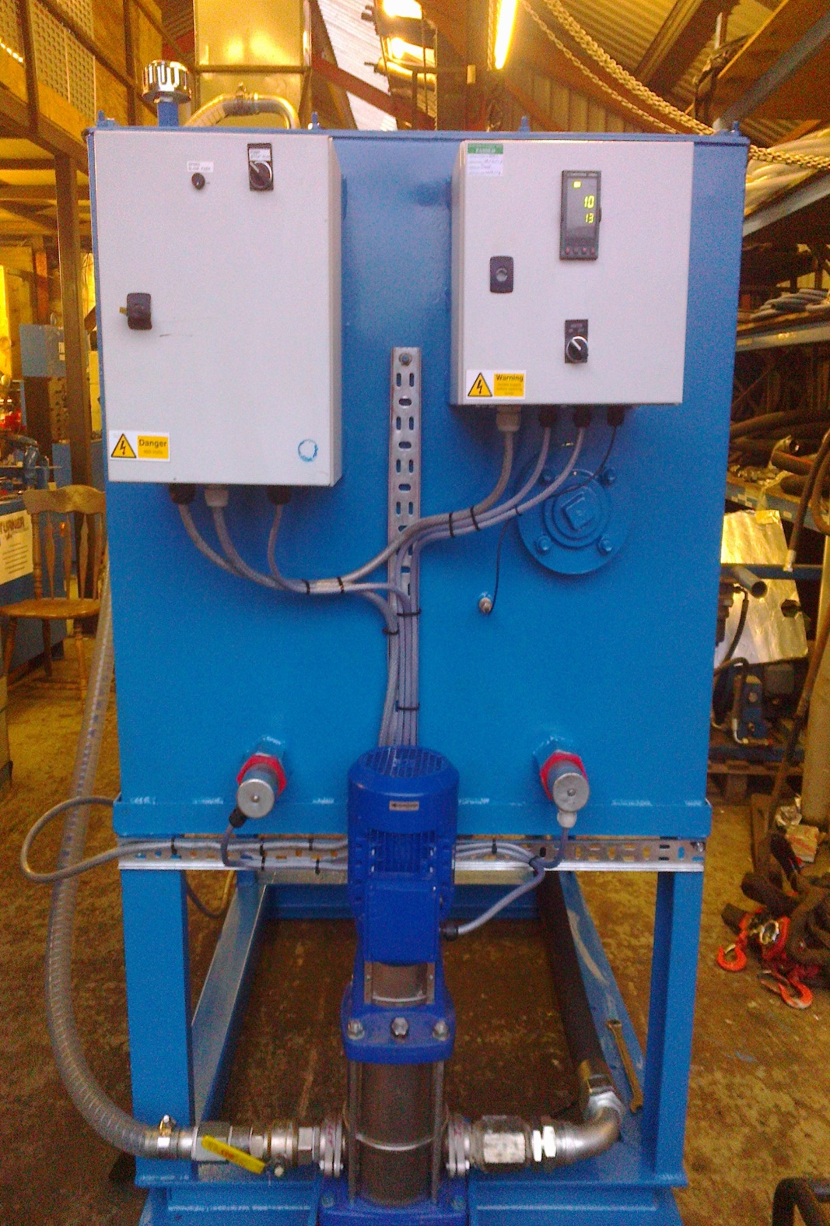
Suction Isolation Valve – always start in Open position.
Under Tank
Pump Bleed Plug
Outlet Isolation Valve – always start in closed position, then open slowly
Heater on / off switch, once on automatic control via above temperature controller
Temperature control set at 50°c

